* Log variable is basically used to print any text, variable and value into console. We do this to test how the test case run.

log.info "hello, this is my first program"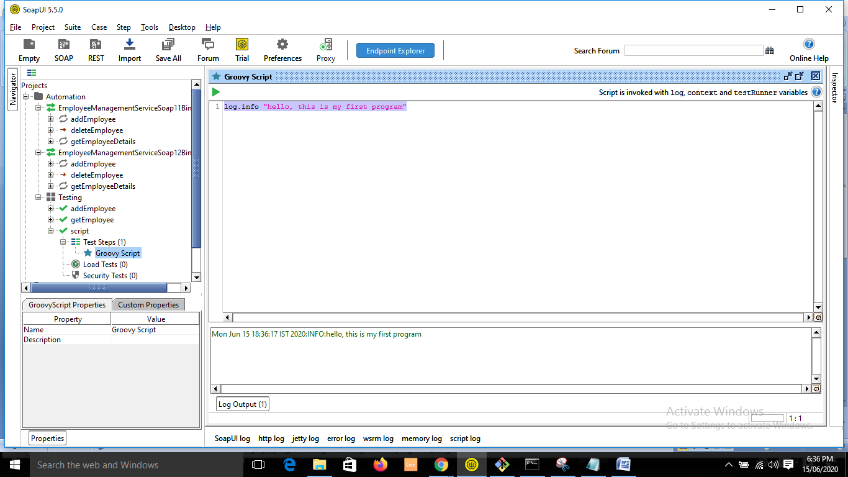

* Context variable is used to manipulate and access or modify the variables and properties of your test case.
* Scope of context lies in Test case only.

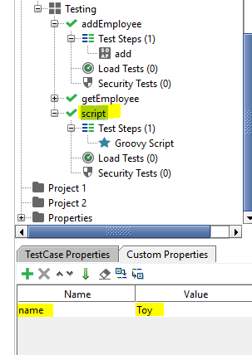

* Groovy script to access name property:

context.expand ('${#TestCase#name}')

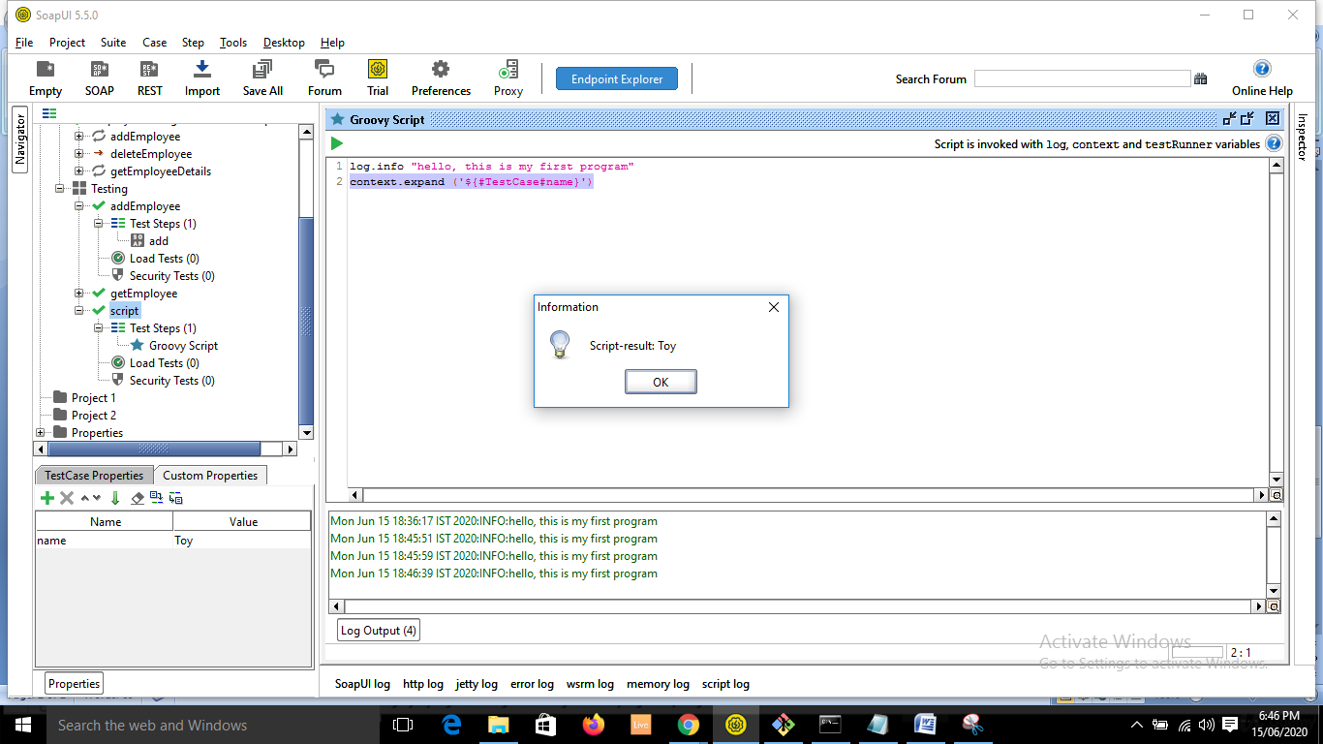

* To print on console:

log.info context.expand ('${#TestCase#name}')

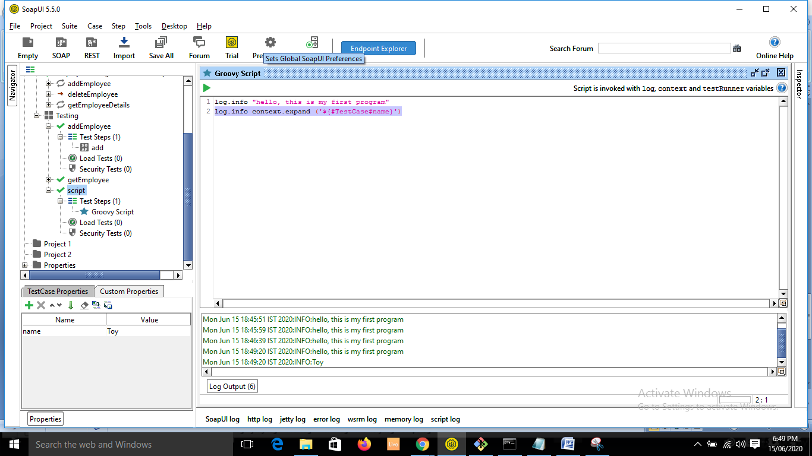

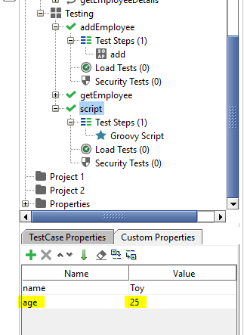

log.info context.expand('${#TestCase#age}')

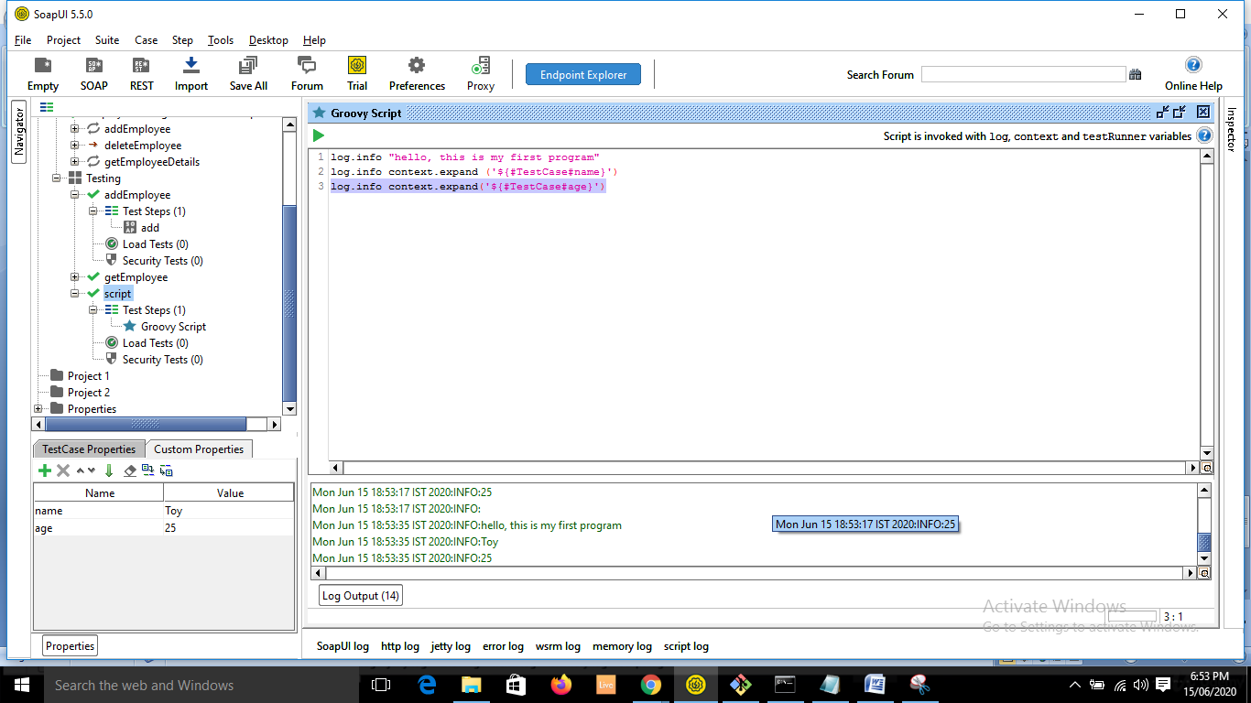

* Disadv is if you want the property from other test cases, you cannot access it using context. 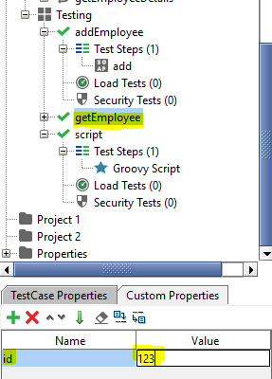
* Under script test case you cannot call this using context. TestRunner will help us to do so.
* It will be like:

log.info testRunner.testCase.testSuite.testCases["getEmployee"].getPropertyValue("id")

* To access any property you have to come through its parent only. 